Spooktacular Bash Sampler Class
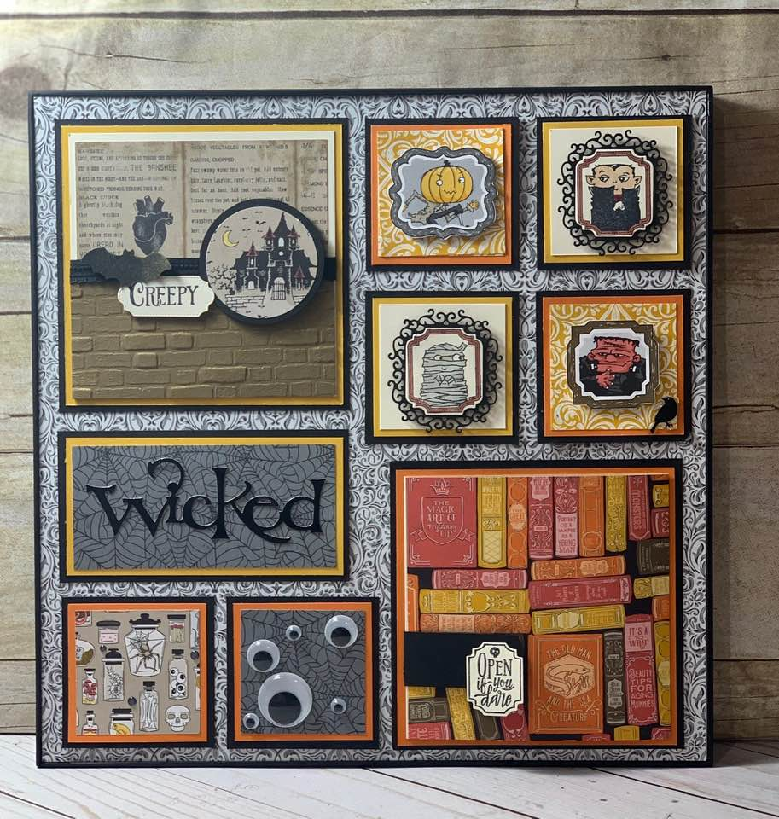
Join us to create a Halloween Sampler using the Spooktacular Bash Stamp set and items from the Monster Bash Suite. With the cost of the class you will receive the Spooktacular Bash Stamp Set.
- Cost: $28.50 with Stamp Set
- Where: 2098 West Cougar Place, Huachuca City AZ
- When: September 21st, 2019 at 10:00
- RSVP: September 15th, 2019 with payment
  - I can take credit cards, Paypal, check, or cash.
- Make payment to Karen Bouchikas at PO Box 4252 Huachuca City, AZ 85616
  - Call or text Karen Bouchikas at (520)234-1298 for RSVP or payment options.
*If you are interested in saving 10% on the Spooktacular Bash Bundle you can purchase this class for the cost of the bundle in which you will receive the Stamp Set and matching Dies for $56.70, which includes tax and shipping.

