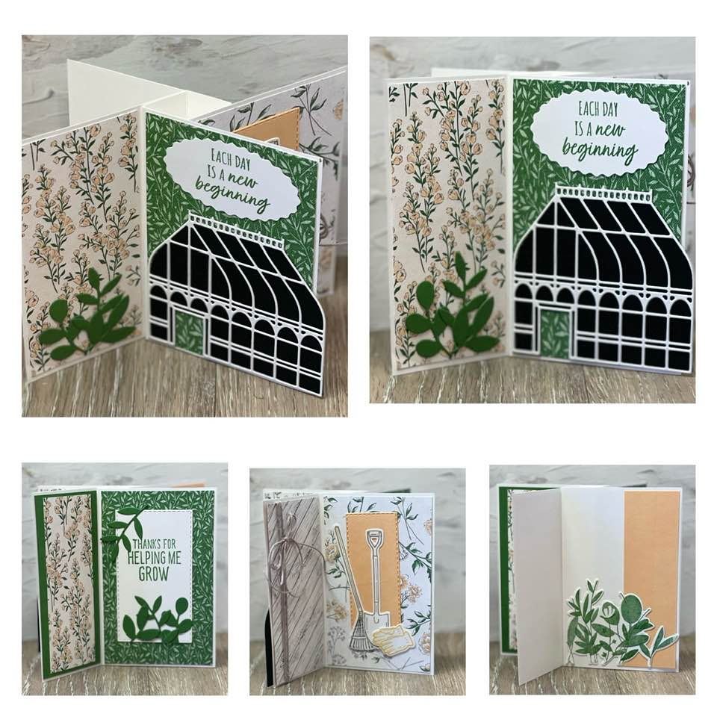

All images © 2022 Stampin’ Up!®

Supplies List
Stamps: Garden Greenhouse Bundle (157733), Home & Garden (147910)
Paper: Basic White 8 ½” x 11” Thick Cardstock (159229), Basic White 8 ½” x 11” Cardstock (159276), Garden Green 8 ½” x 11” Cardstock (102584), Pale Papaya 8 ½” x 11” Cardstock (155668), Basic Black 8 ½” x 11” Cardstock (121045), Heart & Home 12” x 12” Designer Series Paper (127928)
Ink: Garden Green Classic Stampin’ Pad (147089), Pale Papaya Classic Stampin’ Pad (155670), Crumb Cake Classic Stampin’ Pad (147116), Tuxedo Black Memento Ink Pad (132708)
Embellishments: Baker’s Twine Essentials Pack (155475),
Tools: Mini Stampin’ Cut & Emboss Machine (150673), Stitched Rectangle Dies (151820), Double Oval Punch (154242),
Adhesives: Multipurpose Liquid Glue (110755), Mini Glue Dots (103683), Adhesive Sheets (152334)

Measurements
- Thick Basic White – 5 ¾” x 4 ¼”
  - Scored at Scored at ¾”, 1 ½”, 2 ¼”, 3”
- Thick Basic White – 3 - 2 ¾” x 4 ¼”
- 3 – Designer Series Paper strips - 2 5/8” x 4 1/8”
- 2 – Designer Series Paper strips – 2 1/8” x 4 1/8”
- 1 – Garden Green – 2 1/8” x 4 1/8”
- Scrap pieces of Garden Green, Pale Papaya Basic Black and Basic White
Directions
- To create the center of the tower burnish the scored lines on the piece of Thick Basic White (5 ¾” x 4 ¼”)
  - Glue the first small section to the large piece to create a square with a flap coming off of it
- Next glue the three basic white panels (2 ¾” x 4 ¼”) creating the pinwheel shape
- Determine where the card will begin and adhere the coordinating designer series paper
- Stamp the sentiment in Garden Green ink on a scrap piece of Basic White and punch out using the double oval punch
- Die cut out the greenhouse in Basic Black and the overlaying piece in Basic White and adhere together
- Die cut pieces of foliage in Garden Green
- On the beginning section adhere the Designer Series Paper onto the two sections
- Adhere the green house to the bottom of the larger section
- Above the green house adhere the sentiment
- On the smaller section adhere the green leaves over the DSP
- On the next section attach twine to the smaller section’s DSP before tying a bow at the top
- Adhere to the smaller section
- Die cut out a small thin rectangle out of a scrap piece of pale papaya
- Stamp the gloves in pale papaya ink, the shovel in crumb cake, the rake in basic black and crumb cake ink
  - Die cut images out
- Adhere the stitched rectangle piece onto the coordaining piece of DSP
- Adhere the rake, shovel, and gloves over the rectangle
- On the next section adhere the small piece of Garden Green onto the smaller section
- Adhere a die cut piece of DSP using the stitched rectangle dies on top of the Garden Green piece making sure it is centered
- On the larger section die cut a rectangle using the stitched rectangle dies in basic white
- Die cut out leaves in garden green
- Stamp sentiment in garden green ink towards the top of the white rectangle
- Adhere to the larger section making sure that it is centered
- Adhere the green leaves on top of the white rectangle
- On the next section attach a piece of pale papaya that has been die cut out of the stitched rectangle
- Adhere onto the larger section
- Stamp the leaves images onto a scrap piece of basic white and die cut out
- Adhere onto the larger section

5 ¾” x 4 ¼”
Scored at ¾”, 1 ½”, 2 ¼”, 3”

Cut Three Panels – 2 ¾” x 4 ¼”

