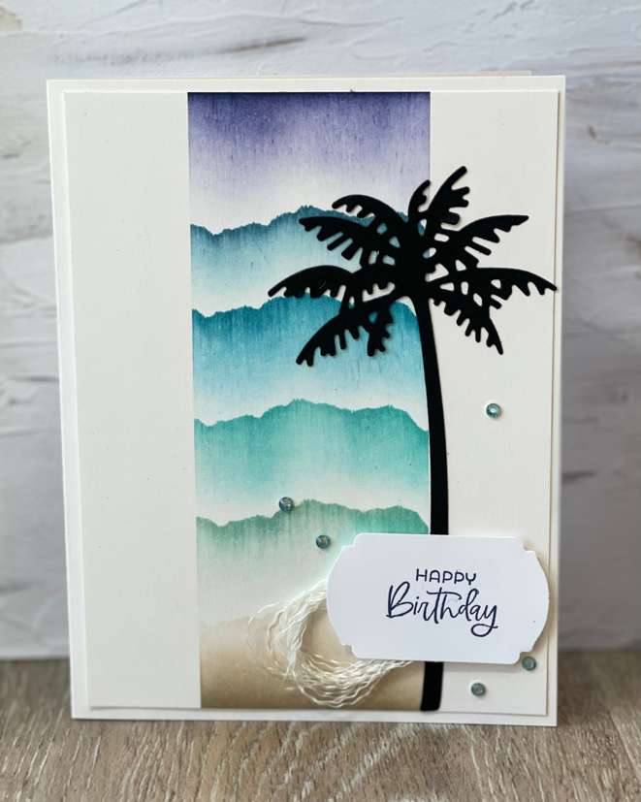

All images © 2022 Stampin’ Up!®

Supplies List
Stamps: Paradise Palms Bundle (149457),
Paper: Shimmery White 8 ½” x 11” Cardstock (101910), Basic Black 8 ½” x 11” Cardstock (121045)
Ink: Crumb Cake Classic Stampin’ Pad (147116), Pool Party Classic Stampin’ Pad (147107) Bermuda Bay Classic Stampin’ Pad (147096), Pacific Point Classic Stampin’ Pad (147098), Misty Moonlight Classic Stampin’ Pad (153118), Night of Navy Classic Stampin’ Pad 9147110)
Embellishments: Rhinestone Waves Basic Jewles (15396)
Tools: Mini Stampin’ Cut & Emboss Machine (150673), Paper Trimmer (152392), Small Grid Paper (149621), post it notes
Adhesives: Multipurpose Liquid Glue (110755), Mini Glue Dots (103683), Adhesive Sheets (152334), Stampin’ Dimenisonals (104430)

Measurements
- Card Base – Shimmery White – 5 ½” x 8 ½” scored at 4 ¼”
- Layer One – Shimmery White – 5 ¼” x. 4”
- Scrap pieces of Basic Black for die cutting
- Scrap piece of Shimmery White
Directions
- Burnish your card base
- Place Layer one onto a small grid sheet
- Align the post it notes from the bottom to the top of the layer vertically making sure to leave about two inches in the middle and the rest is covered by post it notes
- Tear a post it note along the top of the sticky
- Space out your colors so that they are about even
- Lay the torn post it note across the layer towards the bottom
- Using a brush and Crumb Cake blend the curmb cake upward using straight strokes making sure to leave a bit of space towards the post it note that way it will stay white
- Next, using the same torn post it not place it along the open strip. Using pool party and a brush blend the strokes downward making sure to keep a space between pool party and the crumb cake
- Repeat this process for Bermuda Bay, Pacific Point, Misty Moonlight, and Night of Navy
- Remove all post it notes
- Place a strip of adhesive sheet onto the scrap piece of Basic Black
- Die cut the large palm tree out of basic black
- Align the palm tree on the right side of card making sure it overlaps the straight edge that was created through the blending
- Stamp sentiment in Night of Navy onto scrap piece of Shimmery White
- Punch Out
- Cut a length of ribbon – a couple inches long – and cut one of the sides off
- Peel the strands apart
- Add seal to the back of the punched out sentiment and place the strands over it creating a circle that comes out from behind the sentiment
- Adhere using dimensionals towards the bottom of the card making sure it is over the palm tree
- Embellish

